**Sprint 4 Plan**

**Project: Beads Net**

**Team: Weaver**

**Sprint Completion date: 12/02/2018**

**Goal:**

To make an app that can allow users to find a list of similar movies/animes with ranking in spider-web like form by searching names or clicking on tags. It also let users to get the information of the movies and add tags for specific movies.

**Tasklisting：**

**User story 1:** As a user, I want to save the movie or anime I like to my profile so that I can have a quick access to my preferred ones.

Task 1 - Link the profile to database (5hr)

Task 2 - Save the result into database after user click on “like” button (8hr)

Task 3 - Read and display the saved result from database onto profile page (8hr)

Total time for user story 1: 21 hr

**User story 2:** As a user, I want to see a list of results that can be filtered by certain factors after search because I want to have a traditional way of searching for film.

Task 1 - Implement filter feature (13hr)

Task 2 - Users can go to next page of the result (8hr)

Task 3 - Tags are able to search for genre instead of title (5hr)

Task 4 - Anime page can only searched for animation movies (5hr)

Total time for user story 2: 31 hr

**User story 3:** As a user, I want to see different appearance of results, because I want to understand which movie has more rating.

Task 1 - Change the size of the results based on distance. (8hr)

Task 2 - Showing description when mouse over the posters. (5hr)

Task 3 - Be able to present 10+ results (3hr)

Total time for user story 3: 16hr

**User story 4:** As a user, I want the webpage looks neat because I don’t want to use an ugly website.

Task 1 - Improve the sign up/login page design (3hr)

Task 2 - Improve the home page design (3hr)

Task 3 - Improve the result page design (3hr)

Task 4 - Improve the profile page design (3hr)

Total time for user story 4: 12 hr

**Team Roles:**

Zike Peng, Project Owner (Database)

Jiapei Kuang, Developer(Debugger, UI Developer)

Ge Lu, Developer (Scrum Master, UI Developer)

Zidu Chen, Developer(front-end)

Zhiyue Li**,** Scrum Master(front-end)

**Initial Task Assignment:**

Zike Peng: User story 1, Task 1, 2, 3

Jiapei Kuang: User story 2, Initial Task 1 (List view)

Ge Lu: User story 3, User story 2 task 1,2

Zidu Chen: User story 3 task 1,3

Zhiyue Li: User story 2, Task 1

**Initial Burnup Chart:**

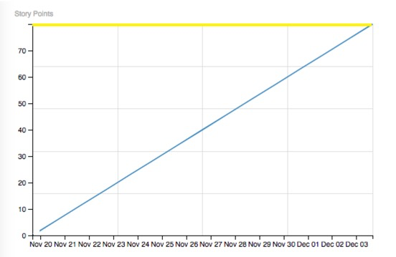

**Initial Scrum Board:**

|  |  |  |  |
| --- | --- | --- | --- |
| User Stories | To Do | In Progress | Done |
| **User story 1:** As a user, I want to save the movie or anime I like to my profile so that I can have a quick access to my preferred ones. |  |  |  |
| **User story 2:** As a user, I want to see a list of results that can be filtered by certain factors after search because I want to have a traditional way of searching for film. |  |  |  |
| **User story 3:** As a user, I want to see different appearance of results, because I want to understand which movie has more rating. |  |  |  |
| **User story 4: (UI improvement )**As a user, I want the webpage looks neat because I don’t want to use an ugly website. |  |  |  |